**Philadelphia University**



**Faculty of Information Technology**

**Department of Software Engineering**

**Examination Paper**

**Lecturer : Ms. Enas Al-Naffar**

**Coordinator : Dr. Samer Hanna**

**Internal Examiner: Dr. Ali Fouad**

**Object-Oriented Programming 721220 Final Exam 2nd semester** **2012-2013**

**Date: 3rd June 2013**  **Section: 1**  **Time**: **120 Minutes**

**Information for Candidates**

1. *This examination paper contains 4 questions. The total is 40.*
2. *The marks for parts of questions are shown in round brackets.*

**I. Basic Notions**

*Objectives: The aim of the question is to evaluate your knowledge and skills concerning with the basic concepts of* ***OOP****.*

**Question 1: [`10 Marks]**

A- Choose the correct answer: [2 Marks, 1 Mark each]

1.  When an object has many forms, it has _____.

A)           Inheritance

B)           Scalability

C)           Encapsulation

D)           Polymorphism

Polymorphism is a concept in object-oriented programming that refers to the ability of a single function, method, or object to operate in different ways depending on the context. It allows one interface to be used for a general class of actions, with the specific action determined by the exact nature of the situation.

2. What part of object-oriented technology defines super-class and sub-class relationships?

A)           Inheritance

B)           Scalability

C)           Encapsulation

D)           Polymorphism

**Inheritance** is the part of object-oriented technology that defines super-class (parent class) and sub-class (child class) relationships. Inheritance allows a class to inherit properties and methods from another class, promoting code reuse and establishing a natural hierarchy between classes.

B- Fill in the blanks with the correct answer: [4 Marks, 1 Mark each]

1. A variable known only within the method in which it is declared is called a(n) ________.

**Local variable**

1. Classes from which objects can be instantiated are called __________ classes.

**Concrete classes**

1. It is possible to have several methods with the same name that each operate on different types or numbers of arguments. This feature is called method __________.

**Overloading**

1. Methods in a class that do not provide implementations must be declared using keyword ________.

**Abstract**

C- State whether each of the following is true or false. If a statement is false, explain why. [4 Marks, 1 Mark each]

1. Base class constructors are not inherited by derived classes.

**True**

* **Explanation**: In object-oriented programming, constructors of the base class are not inherited by derived classes. Each class must define its own constructors. However, a derived class constructor can call a base class constructor to initialize the base part of the derived class object.

1. A has-a relationship is implemented via *inheritance.*

**False**

* **Explanation**: A has-a relationship is implemented via composition, not inheritance. Composition involves creating instances of other classes within a class to use their functionalities. Inheritance, on the other hand, is used to represent an is-a relationship.

1. A Car class has *is-a* relationships with the Steering_Wheel and Brakes classes.

**False**

* **Explanation**: A Car class has a has-a relationship with the Steering_Wheel and Brakes classes because a car contains a steering wheel and brakes as parts. An is-a relationship would imply that a Car is a type of Steering_Wheel or Brakes, which is not correct.

1. When a derived class redefines a base class method by using the same signature and return type, the derived class method is said to overload that base class method

**False**

* **Explanation**: When a derived class redefines a base class method with the same signature and return type, it is called method overriding, not overloading. Method overloading refers to defining multiple methods with the same name but different parameter lists within the same class.

DONE

### II. Familiar Problems Solving

### *Objectives: The aim of the question is to evaluate your basic knowledge of the key aspects of the lectures material and your ability to solve familiar problems.*

**Question 2:** **[15 Marks]**

Study the following class diagram, then write its corresponding c# code.

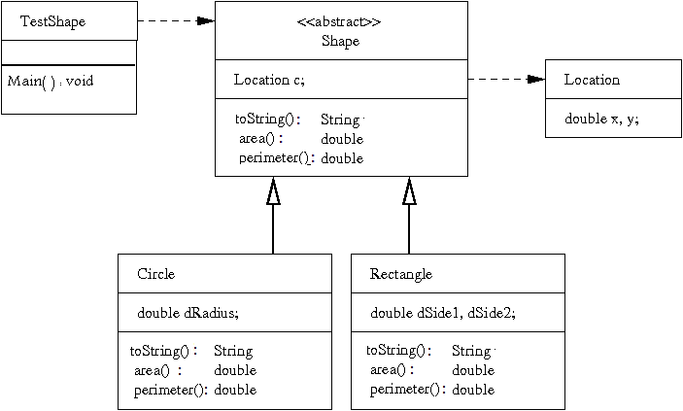

• **Shape (Abstract Class)**

* **Attributes:**
  + Location c; (Associates a location to the shape)
* **Methods:**
  + toString(): String (Abstract method to convert shape details to string)
  + area(): double (Abstract method to calculate the area of the shape)
  + perimeter(): double (Abstract method to calculate the perimeter of the shape)

• **Location (Class)**

* **Attributes:**
  + double x, y; (Coordinates of the location)

• **Circle (Class)**

* Inherits from Shape
* **Attributes:**
  + double dRadius; (Radius of the circle)
* **Methods:**
  + toString(): String (Overrides toString method from Shape)
  + area(): double (Overrides area method from Shape)
  + perimeter(): double (Overrides perimeter method from Shape)

• **Rectangle (Class)**

* Inherits from Shape
* **Attributes:**
  + double dSide1, dSide2; (Sides of the rectangle)
* **Methods:**
  + toString(): String (Overrides toString method from Shape)
  + area(): double (Overrides area method from Shape)
  + perimeter(): double (Overrides perimeter method from Shape)

• **TestShape (Class)**

* **Methods:**
  + Main(): void (Main method for testing the shapes)

**Question 3: [8 Marks]**

Study the following class, and then answer the questions below:

using System;

using System.Collections.Generic;

using System.Linq;

using System.Text;

class Animal

{

protected double weight;

protected double height;

protected int x_coordiantion;

protected int y_coordination;

public animal(double h, double w)

{

x_coordiantion=0;

y_coordination=0;

weight=w;

height=h;

}

public abstract void talk()

{

Console.WriteLine("print from the super class");

}

public void walk(double x, double y)

{

x_coordiantion=x;

y_coordianion =y;

}

}

class cat:Animal

{

private string name;

public cat(double h, double w) : base()

{

name="Putchi";

}

public void talk()

{

return stirng.format("{0}", "meaw");

}

public void drink_milk()

{

Console.WriteLine("iam drinking milk");

}

}

class test

{

Animal a = new cat();

cat c = new cat();

c.talk();

c.walk();

a.talk();

a.walk();

a.drink_milk();

}

The three classes above have some errors . find these erorrs and correct them. **[8 marks]**

***III. Unfamiliar Problems Solving***

Objectives: *The aim of the question is to evaluate your knowledge of the key aspects of the lectures material and your ability to solve unfamiliar problems.*

**Question 4**: **[7 Marks]**

Extend the class **TestShape** in Question 2, by defining a List of type Shape.

* + Create a Method within the same class (**TestShape**) that adds a Shape into the List.
  + Create a Method within the same class (**TestShape**) that deletes a Shape in a given location ( index)
  + Use these newly defend methods in the Main method

Good Luck ☺